38.62: a) The levels are

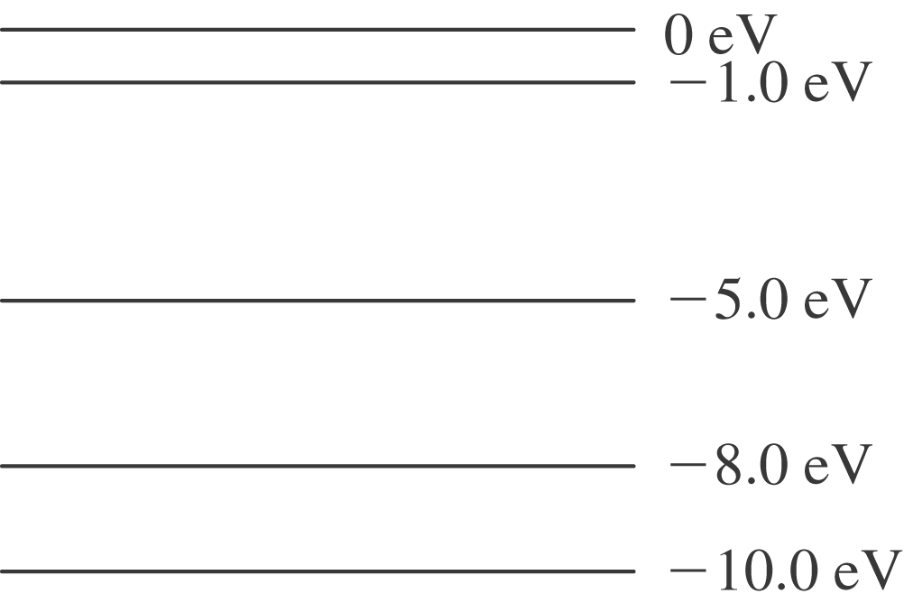

b) We can go from 4-3(4 eV), 4-2(7 eV), and 4-1(9 eV) directly, but also 3-2(3 eV),
3-1(5 eV), and 2-1(2 eV) after starting from 4.

